MMU

1. Mapping local address to physic address
2. Address translation: translate logical addresses into physical addresses, i.e. map the logical address space into a physical address space
3. Given a logical address, MMU finds its logical page, then looks up physical frame in page table.

memory access should not go out of bounds. – If out of bounds, then this is a segmentation fault so trap to the OS. – MMU will detect out-of-bounds memory access and notify OS by throwing an exception

Virtual memory-Physical memory

1. MMU translate
2. Bound checking

What Offset does?

1. MMU in CPU first looks in TLB’s to find a match for a given logical address
2. if match found, then quickly call main memory with physical address frame f (plus offset d)
3. least significant bits = page offset d
4. 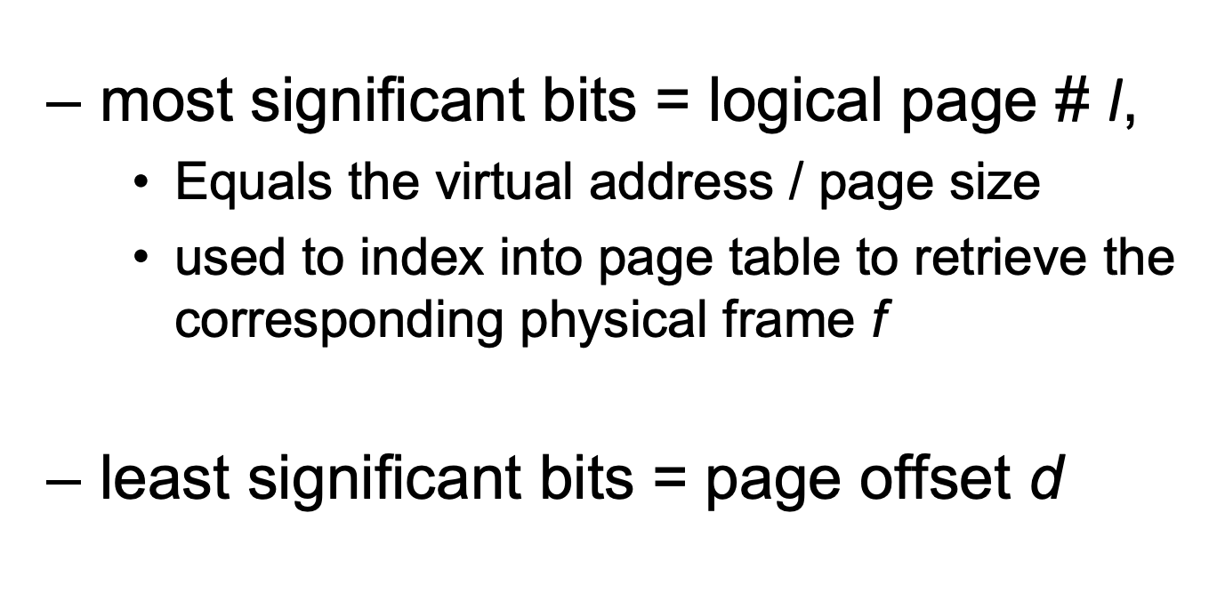

Swapping? Where? When?

1. Disk
2. Not enough free memory.